**Changes in Jankalyan**

**Done**

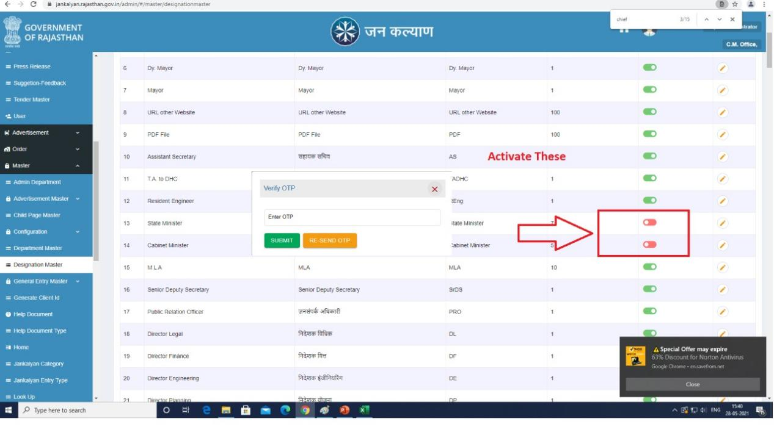**Done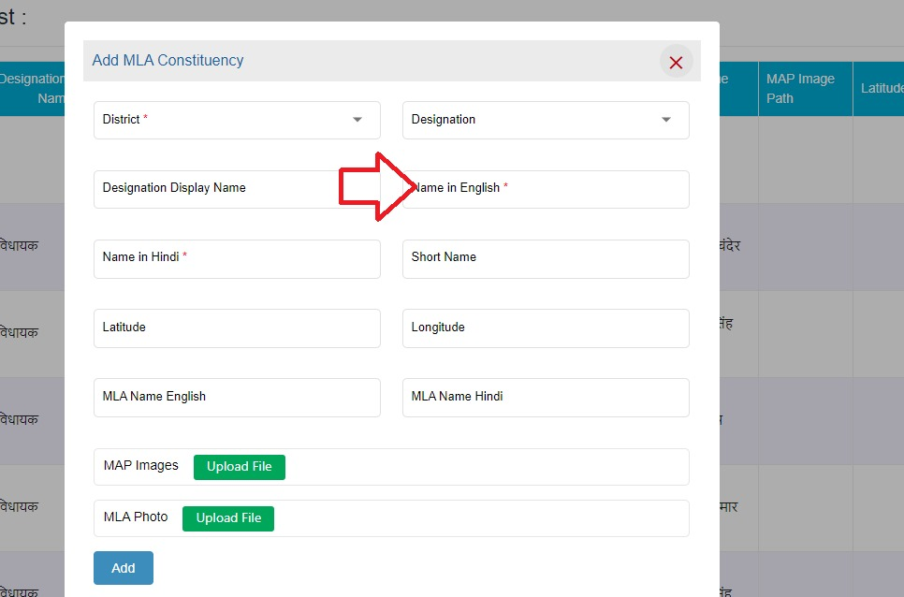Done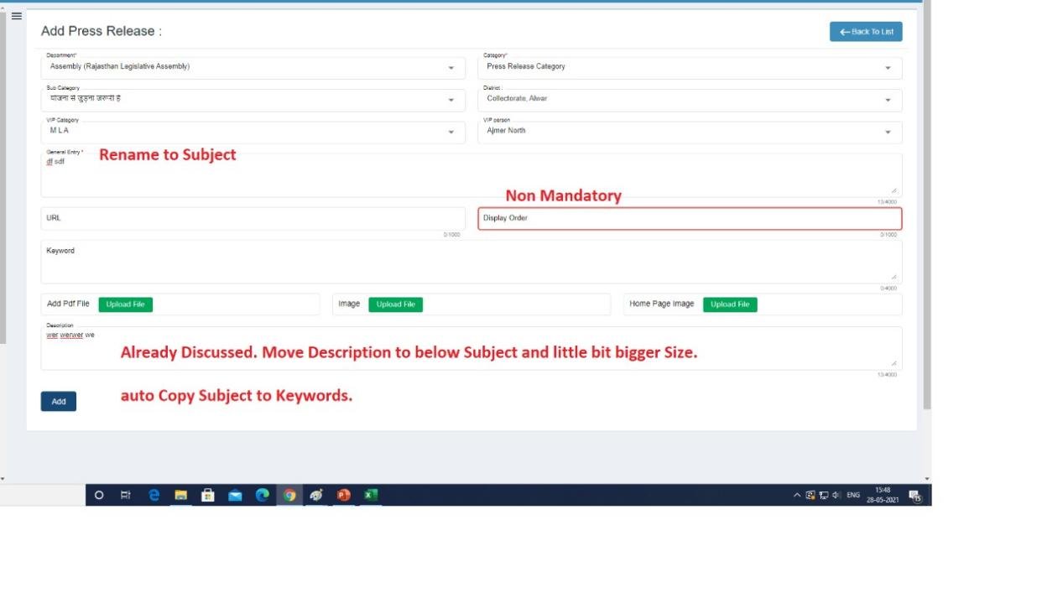Done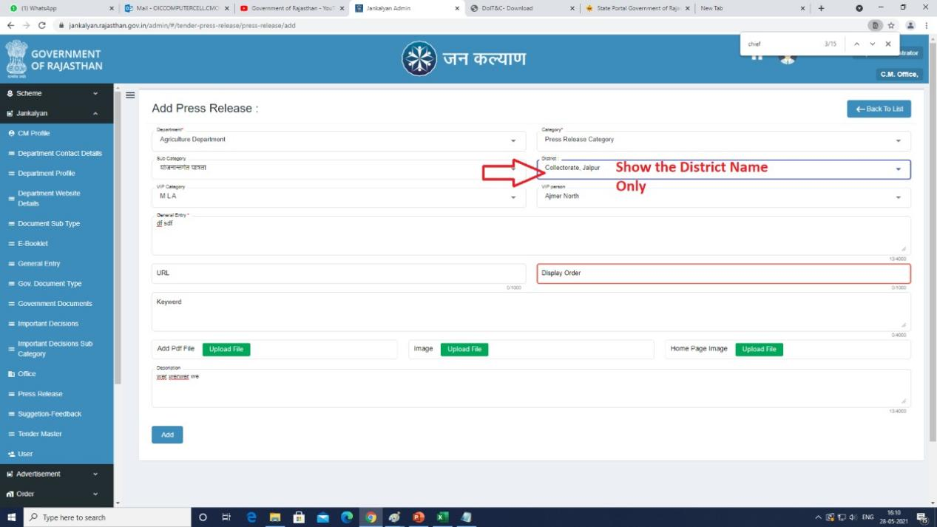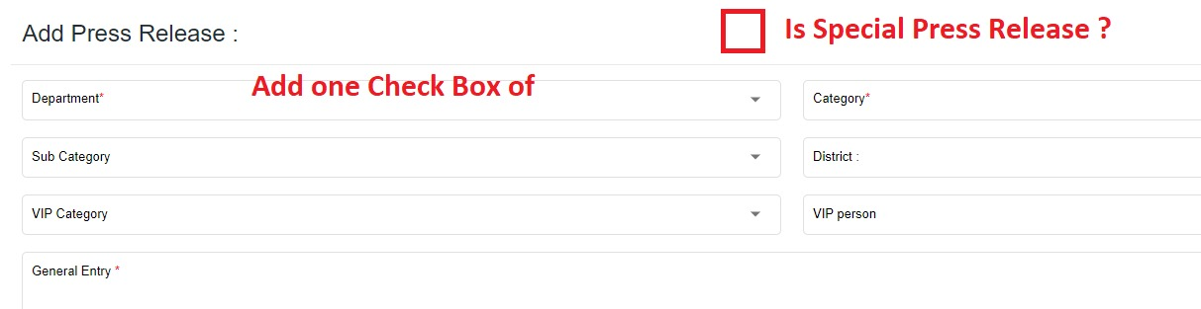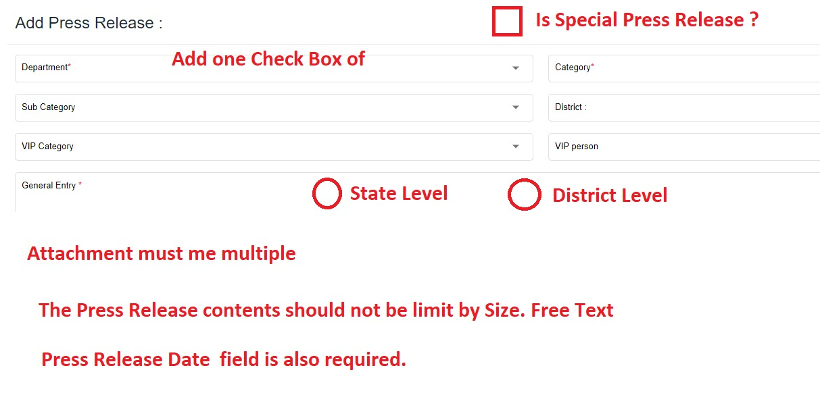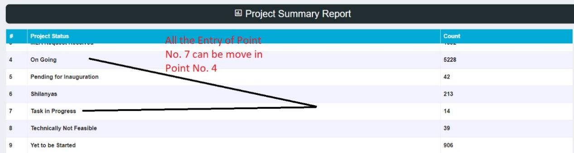Done**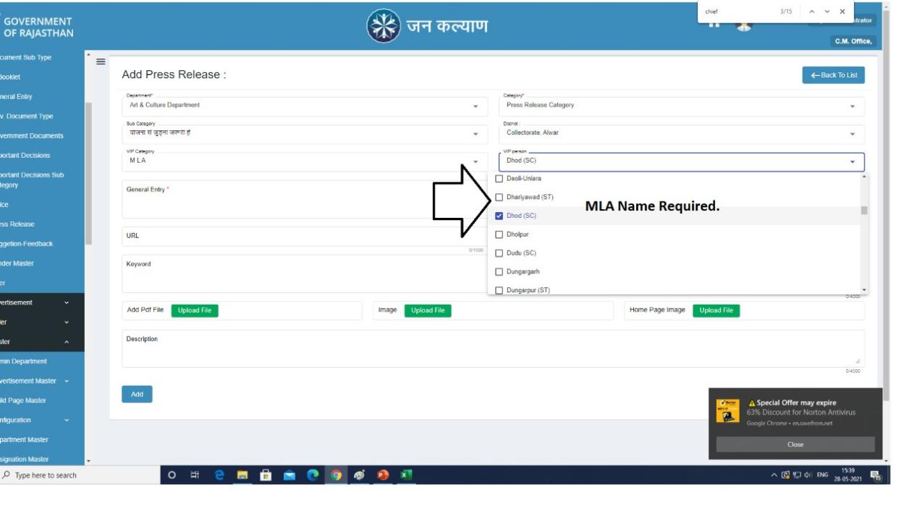

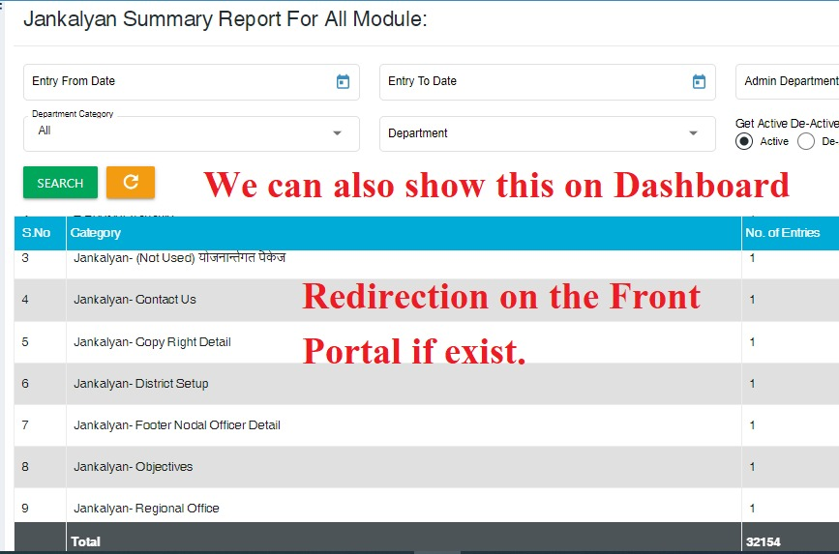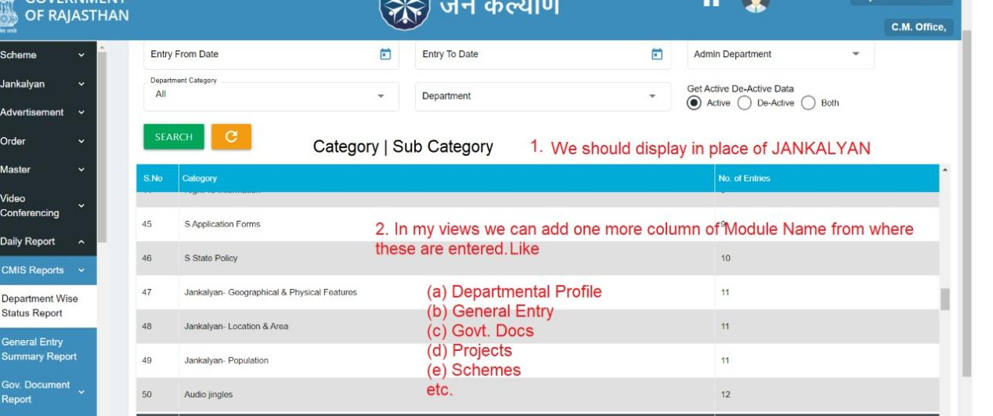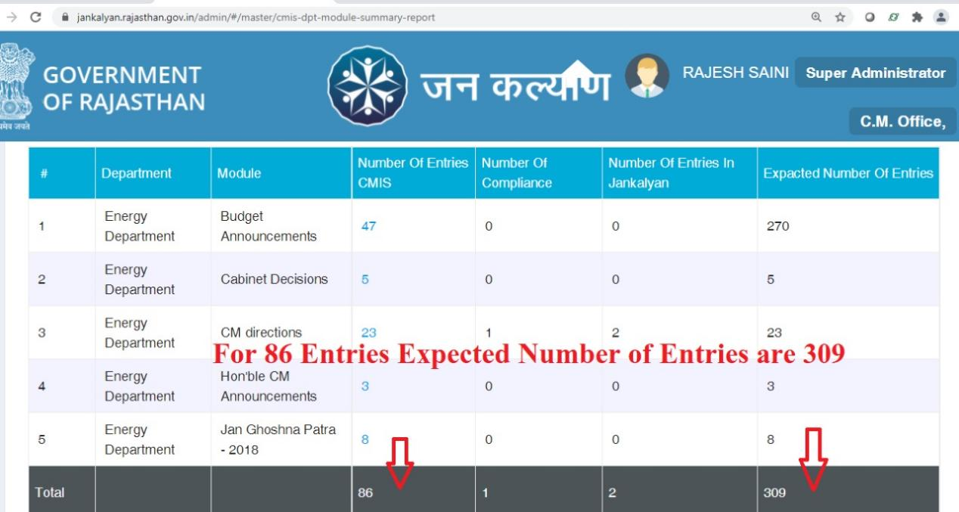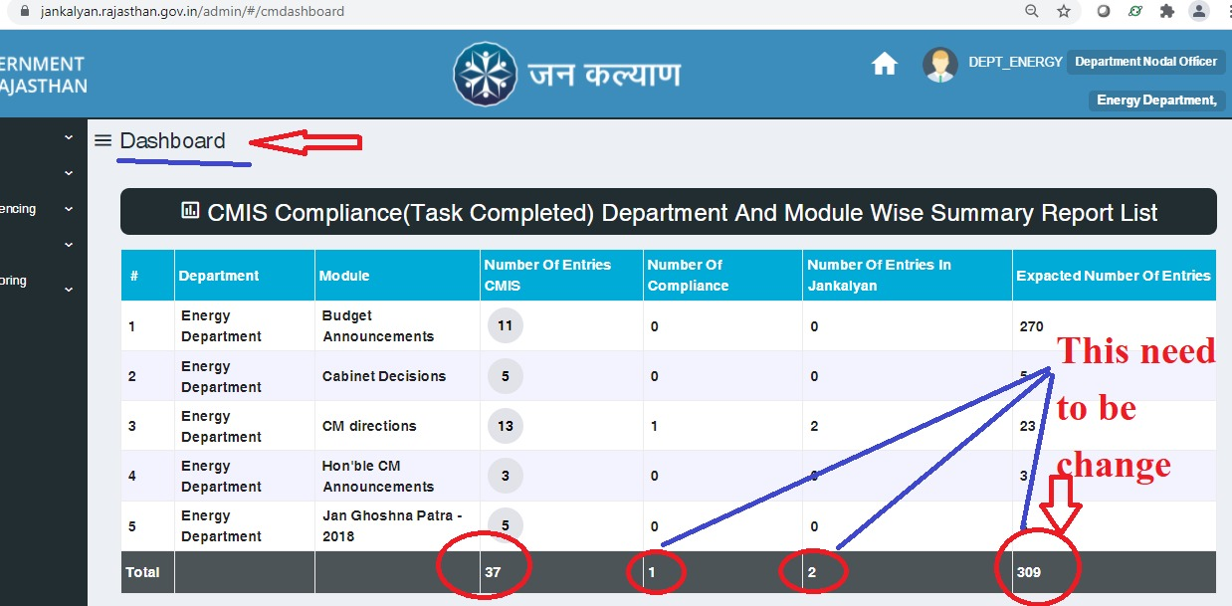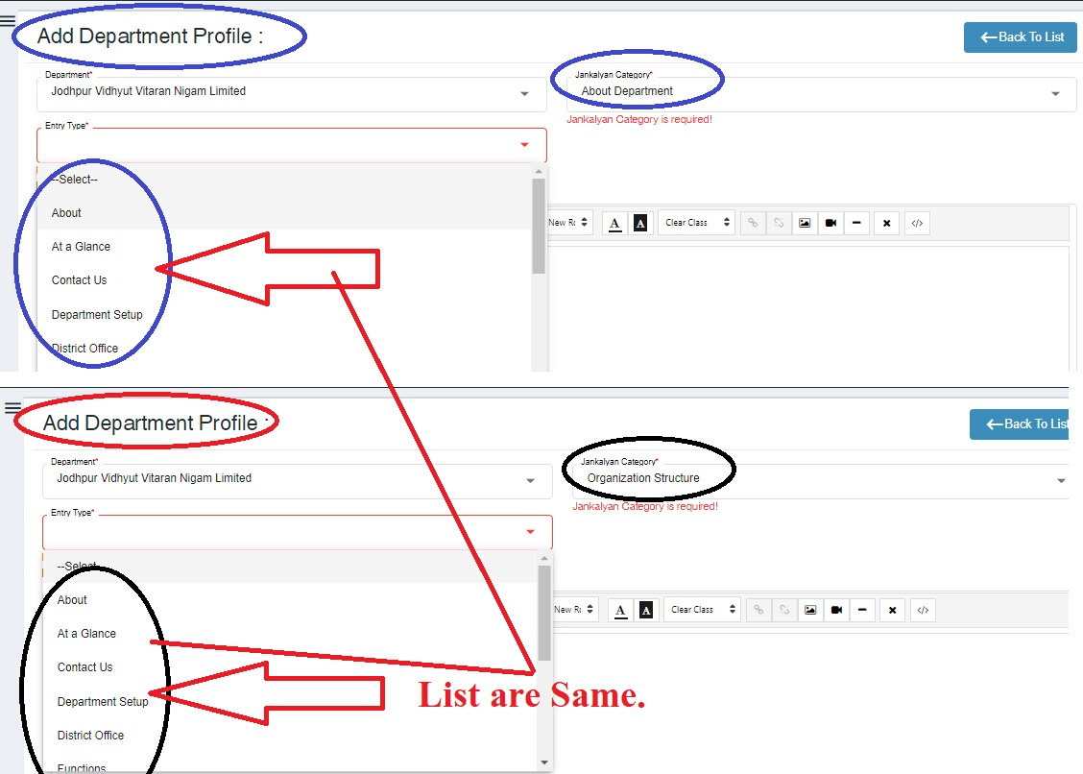

* **Press release in radio button will be hard code(need to be discuss.)**

**Dashboard:**

1. **Add checkbox isshowreport on dashboard.**
2. **On click of checkbox report will be visible ontherwise hide.**
3. **By Default checkbox is checked for all user except super admin .**
4. **Need to check all report on dashboard.**

**PageMaster:**

1. **Add is-visible for permission checkbox.**
2. **On user default permission and specific permission only is-visible for permission data will be show.**
3. **Create trigger to assign default permission to super admin at the time of create new menu in page master.**

**Page master:**

1. **User default permission add button to show user list which has specific permission.**
2. **Open new pop-up there will be two table/grid first table contain only list of user type which has specific permission of particular menu.**
3. **On second table there will be list of user type, user and action button on click of this button remove specific permission for that user.**
4. **Print button on user specific permission screen of list.**

* **In press release screen url name change to “video url”.**
* **Add newdistrictcode in district table.**
* **Set new district code from department table.**

